T24 UPGRADE

**Step 1 :** Download temp.release.tar.z file

**Step 2 :** Check your current directory by running tDiag from your TAFJ/bin

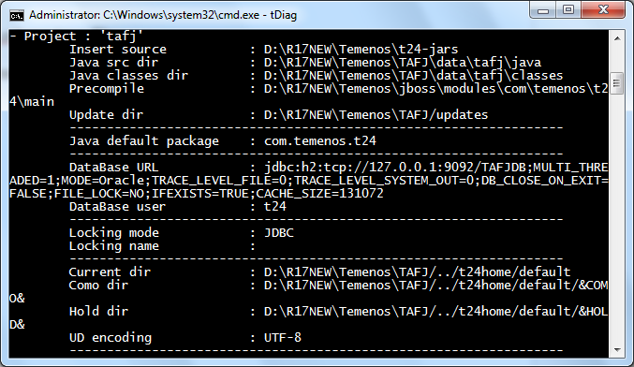

**Step 3 :** Extract temp.release into your current directory

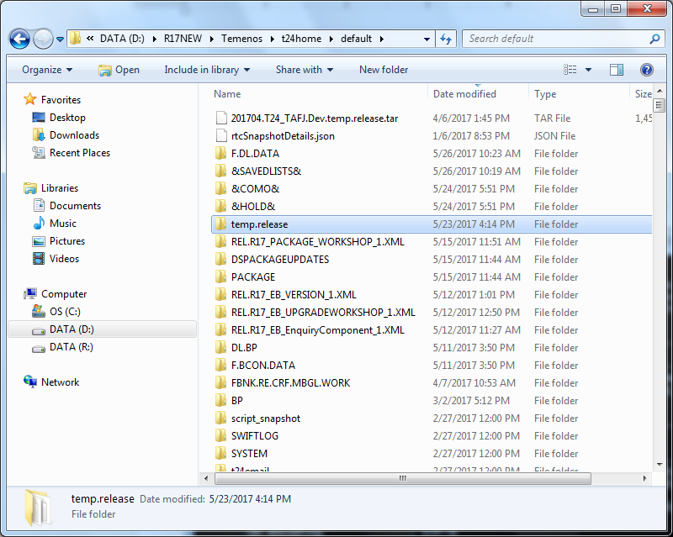

**Step 4 :** Open the Configuration properties file (.properties) in 'TAFJ_HOME/conf'. Add a new property JEDIFILENAME_SYSTEM = SYSTEM

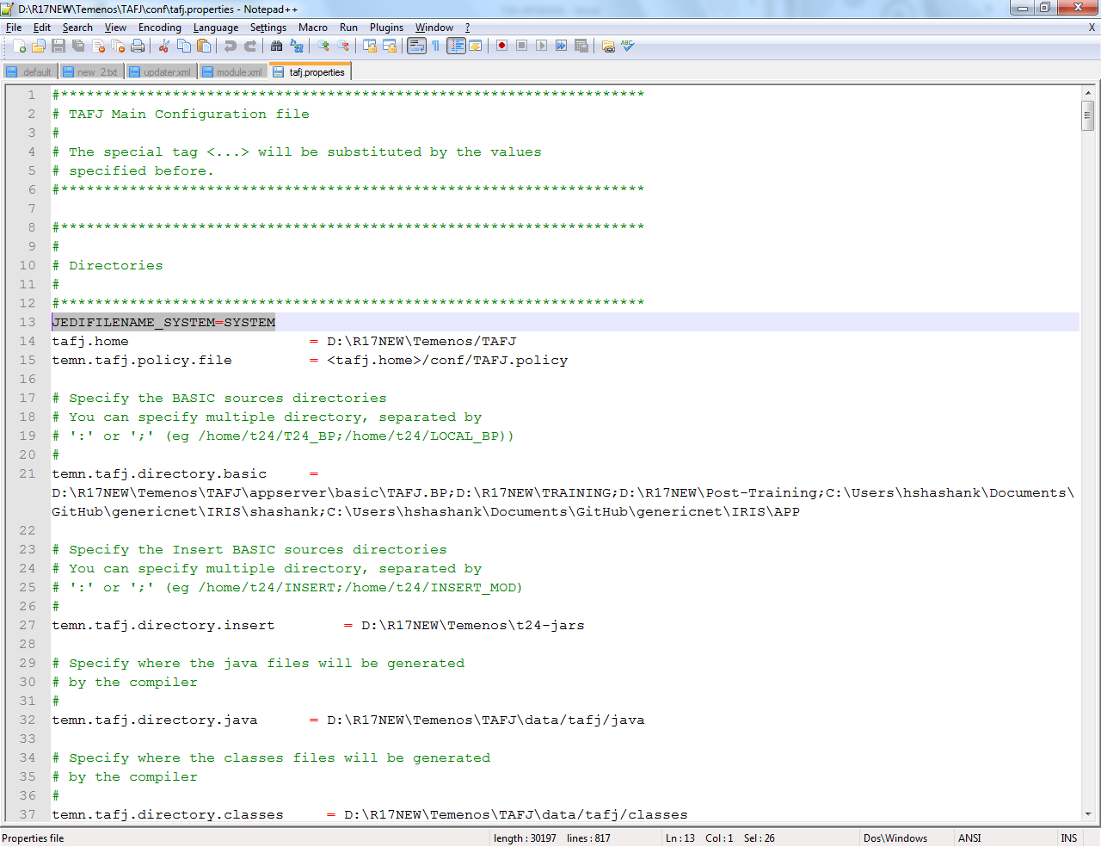

**Step 5 :** Update record named TEMP.RELEASE inside the SYSTEM file as below

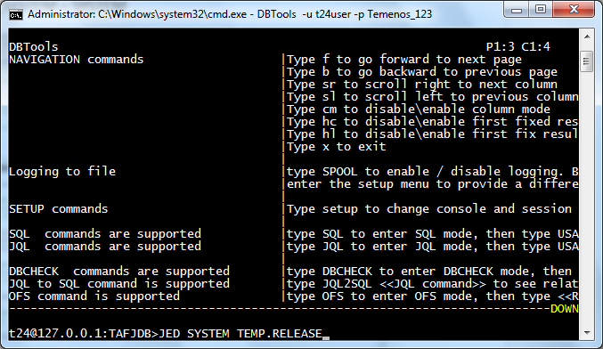

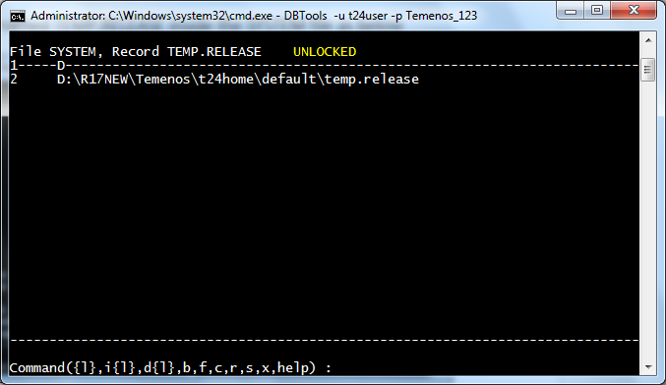

**Type i 2 and give the path of temp.release folder and press Enter**

**Save the record by typing s**

**Step 6 :** To start the upgrade process, launch DBtools under TAFJ_HOME/bin

DBtools [options] TEMP-RELEASE <pathToTempRelease> <pathToPrecompiledDestinationFolder> <-i pathToInsertDestinationFolder> <-bp pathToSrcDestinationFolder>

e.g

DBTools -u t24user -p Temenos_123 -log tmprelease1.log TEMP-RELEASE D:\R17NEW\Temenos\t24home\default\temp.release D:\R17NEW\Temenos\jboss\modules\com\temenos\t24\main -bp D:\R17NEW\Temenos\t24home\default\temp.release\BP

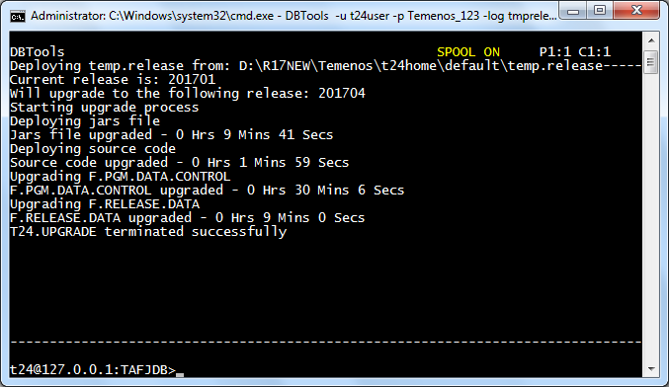

Check your <TAFJ_HOME>/log/DBTools path for the log file created

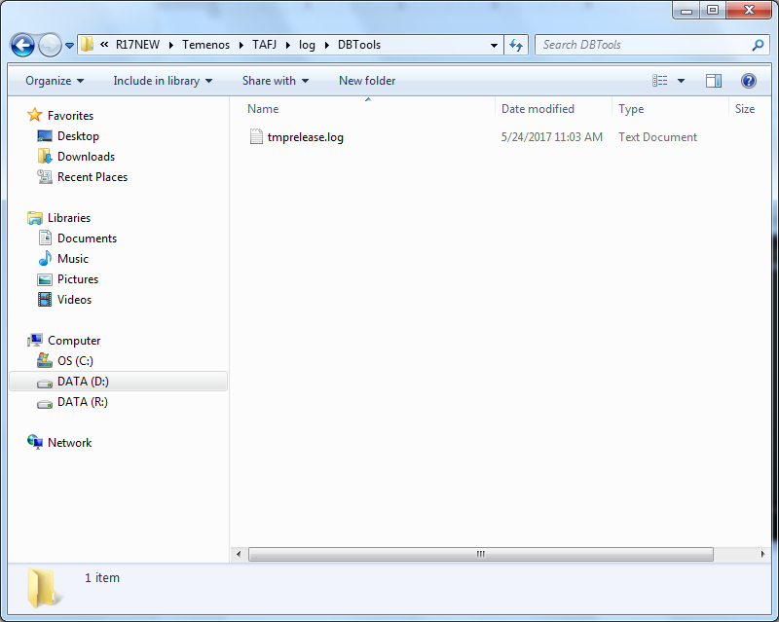

**Step 7 : Run the mainline routine T24.PRE.RELEASE using tRun T24.PRE.RELEASE from your <TAFJ_HOME>/bin**

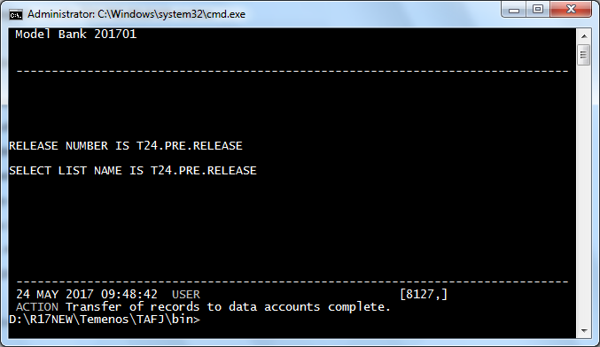

Check T24.PRE.RELEASE file in your <curr_dir>/%SAVEDLISTS% after completion of the routine

**Step 8 :** Run the BNK/T24.UPGRADEservice

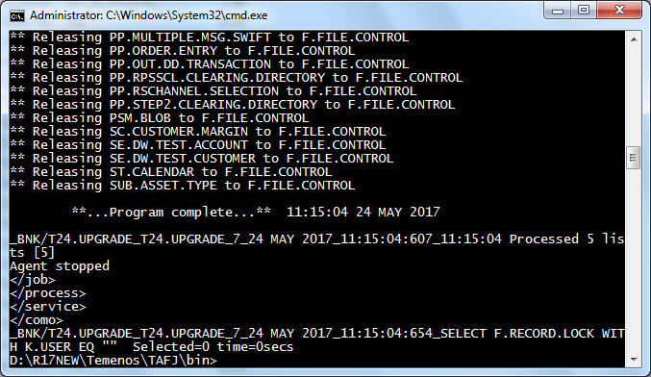

**\*\*\*** Run the agent used for T24.UPGRADE service again and again if it shows up again in TSM

**Step 9 :** Check your SPF file for upgrades

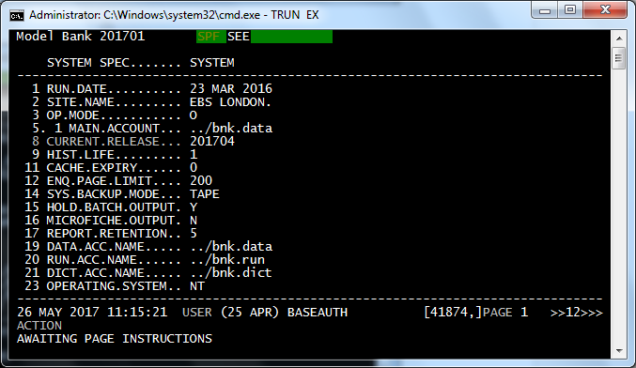

**Step 10 :** Run the Service BNK/RUN.CONVERSION

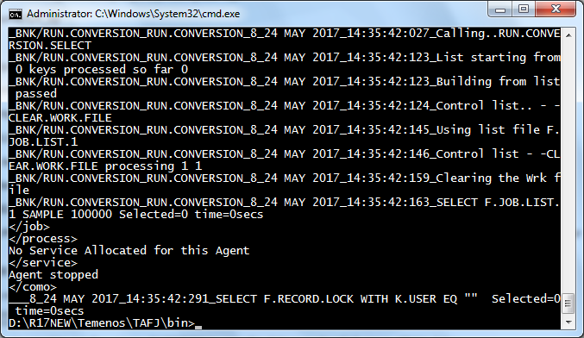

**Step 11 :** Authorise records by running the service BNK/T24.AUTHORISE

The End



Now Start Again